WATCHES

CATEGORY- WOMEN:

1.

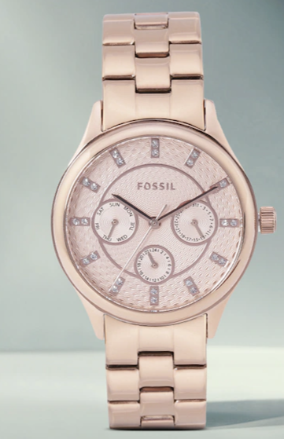

MODERN SOP Women Rose Gold Analogue Watch BQ1561

Price: **₹5997**

#### PRODUCT DETAILS

Display: Analogue  
Movement: Quartz  
Power source: Battery  
Dial style: Textured round stainless steel dial  
Features: Reset Time, Calendar  
Strap style: Rose Gold-Toned regular, stainless steel strap with a foldover closure  
Water resistance: 50 m  
Warranty: 2 years  
Warranty provided by brand/manufacturer  
Comes in a signature Fossil case

#### Size & Fit

Dial width: 35 mm   
Strap width: 19 mm

Dial Shape

Round

# 2. Fire-boltt

# Ninja Fit Smartwatch With Full Touch Display &120+ Sports Modes

Price- **₹1099**

**Features:**

* Color: Beige
* 1.69 HD Large Touch Screen- Fire-Boltt Ninja Fit comes with a 1.69 HD Full Touch Display for smooth swipes and clear vision
* SPO2/ Oxygen, Heart Rate - Fire-Boltt Ninja Fit Smartwatch comes with real time 24*7 SPO2 / Blood Oxygen tracking, Dynamic Heart Rate Monitoring
* 120+ workout modes- This smartwatch consists of 120+ sports mode to track. Keep a track of all your activities and compare history to analyse your performance. Count steps, distance, and calories burned.
* In Built Games - Play games on your watch. With this wide screen and smooth touch experience enjoy playing mini games on the watch
* Multiple Watch Faces- Unlimited Customized Built in Watch Faces and also multiple watch faces through the app;
* Stay Social Stay Updated - Inbuilt social media notifications.
* All In One Smart Coach - Track your Daily Steps, Sleep, Fitness, Sports, Heart Rate and SPO2 Enjoy Music And Camera Control
* Warranty: 1 year
* Warranty provided by Brand/Manufacturer

#### Size & Fit

Dial width: 43 mm  
Strap width: 20 mm

Dial Shape

Square

3. **JOKER & WITCH**

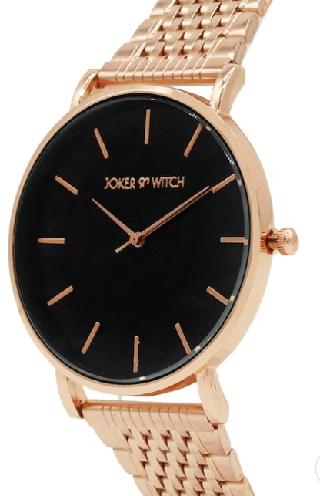

# Women Black Analogue Watch AMWW214

**₹759**

#### PRODUCT DETAILS

Display: Analogue  
Movement: Quartz  
Power source: Battery  
Dial style: Solid round stainless steel dial  
Features: Reset Time  
Strap style: Rose Gold-Toned regular, stainless steel strap with a foldover closure  
Water resistance: Non-Resistant  
Warranty: 1 year  
Warranty provided by brand/manufacturer  
Comes in a signature JOKER & WITCH case

#### Size & Fit

Dial width: 40 mm  
Strap width: 18 mm

Display

Analogue

Dial Shape

Round

# 4. French Connection

# 

# Women Rose Gold Analogue Watch FCL0001A

**₹2780**

#### PRODUCT DETAILS

Display: Analogue  
Movement: Quartz  
Power source: Battery  
Dial style: Solid round stainless steel dial  
Features: Reset Time  
Strap style: Rose Gold-Toned bracelet style, stainless steel strap with a foldover closure  
Water resistance: 30 m  
Warranty: 1 year  
Warranty provided by brand/manufacturer  
Comes in a French Connection box

Display

Analogue

Dial Shape

Round

# 5. Fossil

# 

# Women Cream-Coloured Analogue Watch ES4319_FSS

**₹7197**

#### PRODUCT DETAILS

Display: Analogue  
Movement: Quartz  
Power source: Battery  
Dial style: Solid round stainless steel dial  
Features: Reset Time, Date Aperture  
Strap style: Steel Toned bracelet style, stainless steel strap with a foldover closure  
Water resistance: 50 m  
Warranty: 1 year from the date of purchase  
Warranty provided by brand/manufacturer

#### Size & Fit

Dial width: 35 mm  
Strap width: 20 mm

Display

Analogue

Dial Shape

Round

# 6. Titan

# 

# Women Purple Analogue Watch 2480WM02

**Rs. 4860**

#### PRODUCT DETAILS

Display: Analogue  
Movement: Quartz  
Power source: Battery  
Dial style: Embellished round stainless steel dial  
Features: Reset Time  
Strap style: Rose Gold-Toned bracelet style, stainless steel strap with a foldover closure  
Water resistance: 50 m  
Warranty: 2 years  
Warranty provided by brand/manufacturer  
Comes in a Titan case

#### Size & Fit

Dial width: 35 mm  
Strap width: 15 mm

Display

Analogue

Dial Shape

Round

# 7. JOKER & WITCH

# 

# Women Black Analogue Watch AMWW239

#### **₹599** PRODUCT DETAILS

Display: Analogue  
Movement: Quartz  
Power source: Battery  
Dial style: Solid round stainless steel dial  
Features: Reset Time  
Strap style: Black wrap around, synthetic strap with a tang closure  
Water resistance: 1 ATM  
Warranty: 1 year  
Warranty provided by brand/manufacturer  
Comes in a signature JOKER & WITCH case

#### Size & Fit

Dial width: 40 mm  
Strap width: 20 mm

Display

Analogue

Dial Shape

Round

# 8. Daniel Klein

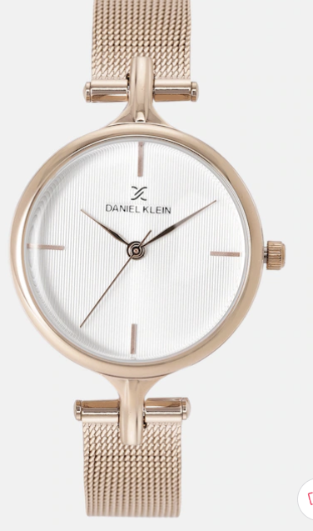

# Premium Women Off-White Analogue Watch DK11914-5

**₹2425**

#### PRODUCT DETAILS

Display: Analogue  
Movement: Quartz  
Power source: Battery  
Dial style: Textured round stainless steel dial  
Features: Reset Time  
Strap style: Rose Gold-Toned bracelet style, stainless steel strap with a foldover closure  
Water resistance: 30 m  
Warranty: 2 years  
Warranty provided by brand/manufacturer

#### Size & Fit

Dial width: 30 mm  
Strap width: 15 mm

Display

Analogue

Dial Shape

Round

# 9. DressBerry

# 

# Women Brown Analogue Watch

**1259**

#### PRODUCT DETAILS

Display: Analogue  
Movement: Mechanical  
Power source: Battery  
Dial style: Solid round stainless steel dial  
Features: Reset Time  
Strap style: Rose Gold-Toned bracelet style, stainless steel strap with a foldover closure  
Water Resistant

#### Size & Fit

Dial width: 35 mm  
Strap width: 18 mm

Display

Analogue

Dial Shape

Round

# 10. DressBerry

# 

# Women Blue Analogue Watch MFB-PN-WTH-9645L

#### **949** PRODUCT DETAILS

Display: Analogue  
Movement: Mechanical  
Power source: Battery  
Dial style: Embellished round stainless steel dial  
Features: Reset Time  
Strap style: Blue bracelet style, stainless steel strap with a foldover closure  
Water Resistant

#### Size & Fit

Dial width: 40 mm  
Strap width: 20 mm

Display

Analogue

Dial Shape

Round

Category – Men

1. Roadster

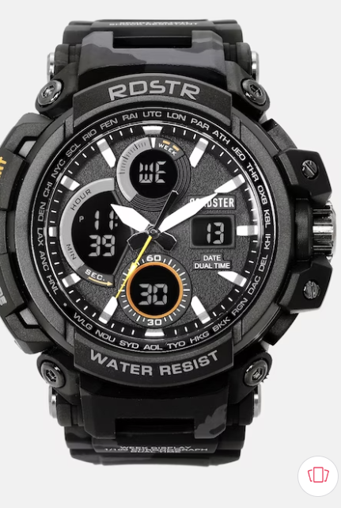

# The Lifestyle Co Men Black Multi Function Analogue and Digital Watch MFB-PN-SM-1708

**Rs. 2899**

#### PRODUCT DETAILS

Display: Analogue and Digital  
Movement: Quartz  
Power source: Battery  
Dial style: Solid round stainless steel dial  
Features: Multi Function, Stopwatch, Chronograph  
Strap style: Black regular, silicon strap with a tang closure  
Water resistance: Water Resistant  
Comes in a signature Roadster case

#### Size & Fit

Dial width: 30 mm  
Strap Width: 25 mm

Display

Analogue and Digital

Dial Shape

Round

1. WROGN

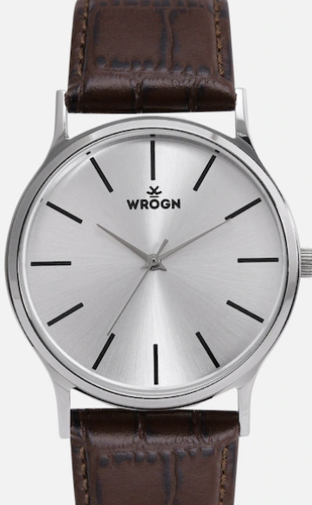

# Men Silver-Toned Analogue Watch WRG00048A

**₹799**

#### PRODUCT DETAILS

Display: Analogue  
Movement: Quartz  
Power source: Battery  
Dial style: Printed round brass dial  
Features: Reset Time  
Strap style: Blue regular, synthetic strap with a tang closure  
Water resistance: 30 m  
Comes in a signature WROGN case

#### Size & Fit

Dial width:  
Strap Width

Display

Analogue

Dial Shape

Round

1. MASERATI

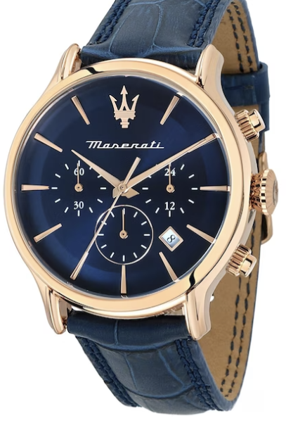

# Men Embellished Dial Leather Bracelet Style Straps Analogue Watch R8871618013

**₹21140**

#### PRODUCT DETAILS

Pack Contains: single watch  
Display: analogue  
Movement: quartz  
Power Source: battery  
Dial style: blue embellished Round stainless steel dial  
Features: reset time  
Strap Style: blue, bracelet style, leather strap with a foldover  
Water resistance: 100 m  
Comes in a signature Maserati case  
Warranty: 2 years  
Warranty provided by brand owner/manufacturer

Display

Analogue

Dial Shape

Round

1. TITAN

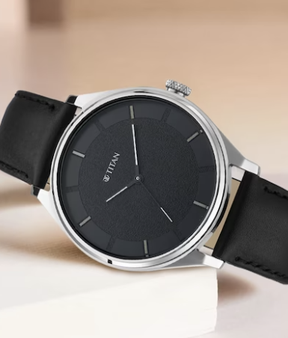

# Men Black Analogue Watch

#### **₹2985** PRODUCT DETAILS

Display: Analogue  
Movement: Quartz  
Power source: Battery  
Dial style: Solid round brass dial  
Features: Reset Time  
Strap style: Black regular, leather strap with a tang closure  
Water resistance: 50 m  
Warranty: 2 years  
Warranty provided by brand/manufacturer  
Comes in a signature Titan case

#### Size & Fit

Dial width:  
Strap Width

Display

Analogue

Dial Shape

Round

1. CASIO

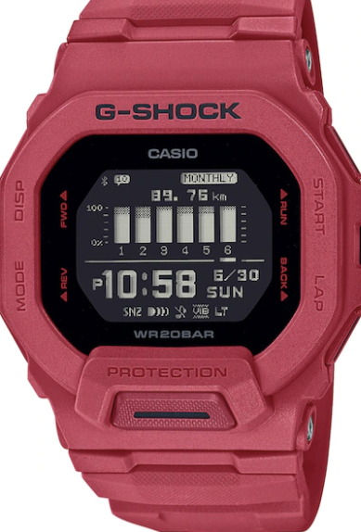

# G-SHOCK Men Black Dial & Red Straps Digital Bluetooth Watch G1203 GBD-200RD-4DR

**Rs. 12995**

#### PRODUCT DETAILS

Pack Contains: single watch  
Display: digital  
Movement: quartz  
Power Source: battery  
Dial style: black solid square resin dial  
Features: bluetooth,  
Strap Style: red, regular, rubber strap with a foldover  
Water resistance: 200 m  
Comes in a signature CASIO case  
Warranty: 2 years  
Warranty provided by brand owner/manufacturer

Dial Shape

Square

1. ROADSTER

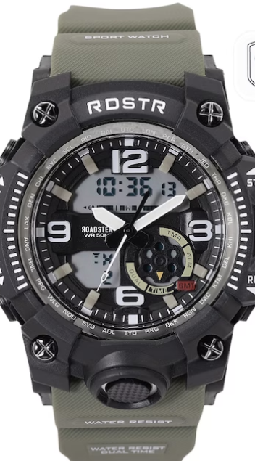

# Men Dial & Cut Work Straps Analogue and Digital Watch MFB-PN-SM-8617

**874**

#### PRODUCT DETAILS

Pack Contains: single watch  
Display: analogue and digital  
Movement: quartz  
Power Source: battery  
Dial style: black solid round stainless steel dial  
Features: multi function, reset time, alarm  
Strap Style: green, cut work silicon strap with a tang closure  
Water resistance: 50 m  
Comes in a Roadster case

Display

Analogue and Digital

Dial Shape

Round

1. FOSSIL

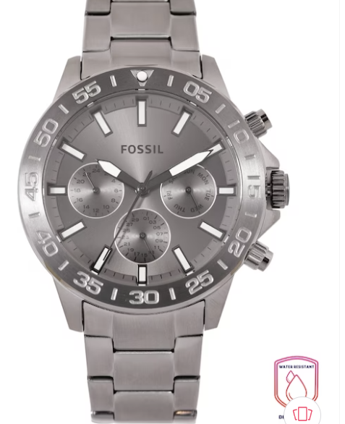

# Men Grey Bracelet Style Analogue Watch BQ2491

**10496**

#### PRODUCT DETAILS

Pack Contains: single watch  
Display: analogue  
Movement: quartz  
Power Source: battery  
Dial style: grey solid round stainless steel dial  
Features: reset time,  
Strap Style: grey, bracelet style, stainless steel strap with a foldover  
Water resistance: 50 m  
Comes in a signature Fossil case  
International warranty: 2 years against material and manufacturing defects  
Warranty provided by brand owner/manufacturer  
Disclaimer - The Watch Cases might differ from the image shown.

Display

Analogue

Dial Shape

Round

1. **Daniel Klein**

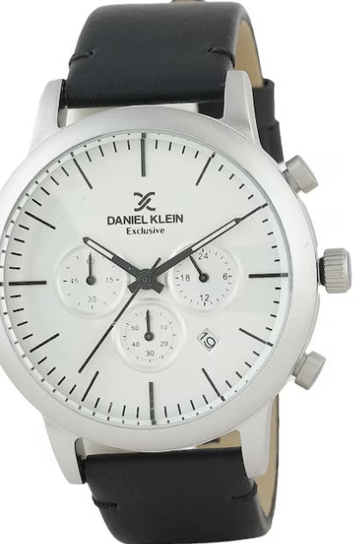

# Men Leather Straps Analogue Watch DK12162-2

**3451**

#### PRODUCT DETAILS

Pack Contains: Single Watch  
Display: Analogue  
Movement: Quartz  
Power Source: Battery  
Dial Style: Silver-Toned Solid Round Metal Dial  
Features: Reset Time, ,  
Strap Style: Black, Regular, Leather Strap with A Tang  
Water Resistance: 50 M  
Comes in A Signature Daniel Klein Case  
Warranty: 1 Year  
Warranty Provided by Brand Owner/manufacturer

Display

Analogue

Dial Shape

Round

1. FOSSIL

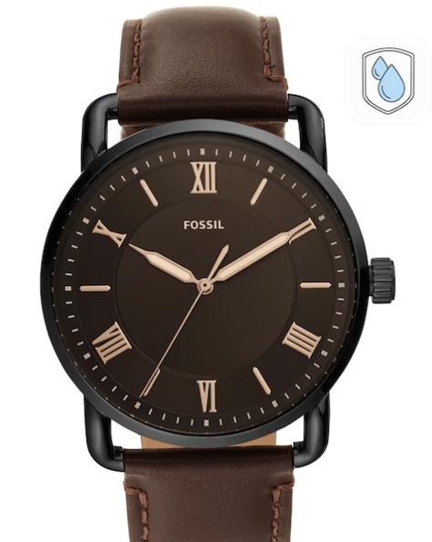

# Men Brown Analogue Leather Watch FS5666

**5997**

#### PRODUCT DETAILS

Display: Analogue  
Movement: Quartz  
Power source: Battery  
Dial style: Solid round metal dial  
Features: Reset Time  
Strap style: Brown regular, leather strap with a tang closure  
Water resistance: 50 m  
Warranty: 2 years  
Warranty provided by brand/manufacturer  
  
Disclaimer - The Watch Cases might differ from the image shown.

#### Size & Fit

Dial width: 42 MM  
Strap width: 22 MM

Display

Analogue

Dial Shape

Round

1. **FASTRACK**

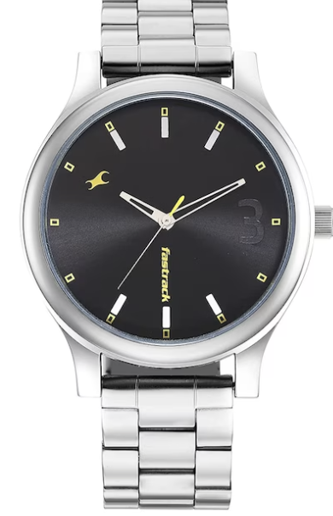

# Men Black Dial & Steel Toned Bracelet Style Straps Analogue Watch 38069SM01

**1317**

#### PRODUCT DETAILS

Pack Contains: single watch  
Display: analogue  
Movement: quartz  
Power Source: battery  
Dial style: black solid round brass dial  
Features: reset time,  
Strap Style: steel toned, bracelet style, stainless steel strap with a foldover  
Water resistance: 50 m  
Comes in a signature Fastrack case  
Warranty: 1 year  
Warranty provided by brand owner/manufacturer

Display

Analogue

Dial Shape

Round

Category- unisex

* 1. FASTRACK
  2. 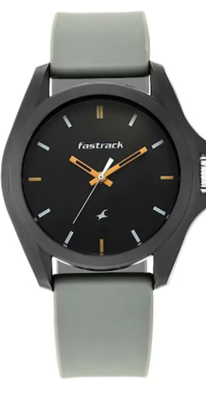

# Unisex Black Dial & Grey Straps Tees Fast Fit Analogue Watch 68011PP08

**897**

#### PRODUCT DETAILS

Pack Contains: single watch  
Display: analogue  
Movement: quartz  
Power Source: battery  
Dial style: black solid round plastic dial  
Features: reset time,  
Strap Style: grey, regular, silicon strap with a tang closure  
Water resistance: 30 m  
Comes in a signature Fastrack case  
Warranty: 6 months  
Warranty provided by brand/ manufacturer  
Disclaimer - The Watch Cases might differ from the image shown.

Display

Analogue

Dial Shape

Round

# 2. NOISE

# 

# ColorFit Caliber Buzz Smartwatch

**₹2399**

#### PRODUCT DETAILS

**Features:**

* Color: Pink
* 1.69' inch TFT display with 500 nits brightness and 240*280px
* Noise Buzz features call from dial pad, access recent calls and save up to 10 contacts
* Bluetooth calling equipped with Tru Sync with Call Function Touchscreen Fitness & Outdoor
* Battery Runtime: Upto 7 days
* Warranty: 1 year
* Warranty provided by Brand/Manufacturer

#### Size & Fit

Dial width: 42 mm  
Strap width: 20 mm

Display

Digital

Dial Shape

Rectangular

* 1. BOAT

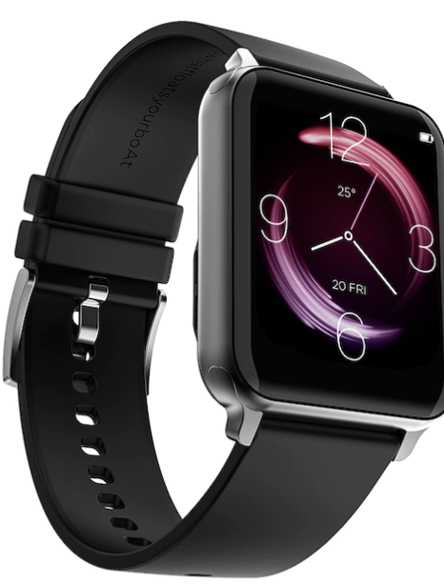

Storm Call 1.69 inch HD Display With Bluetooth Calling Smartwatch

**2999**

#### PRODUCT DETAILS

**Features:**

* The boAt Storm Call is the perfect companion for your fitness transformation.
* Your Watch Storm Call is here to remove all obstructions that may come on your goal achieving path.
* The watch comes with Bluetooth calling and a Dialpad that saves up to 10 contacts, for you to stay connected 24x7.
* With its daily activity tracker and multiple sports modes, it will now be fun to track your journey towards health.
* Stay alert at all times with smart notifications from your phone with vibration alerts for calls, texts, sedentary reminders, alarms, & more
* The wellness mode of the smartwatch monitors your heart rate, blood oxygen levels.
* And when you want to disconnect with the outside world, theres the DND feature on the watch to disable all notifications.
* Its find my phone feature will call your phone to easily locate your phone when you dont remember where you kept it
* The IP68 dust, sweat and splash resistance will keep the watch safe in all circumstances
* Moreover, you can customize your watch face with cloud based watch faces on Storm Call to flaunt your fitness wherever you go
* Warranty: 1 year
* Warranty provided by Brand/Manufacturer

#### Size & Fit

Dial width: 42 mm  
Strap width: 20 mm

Display

Digital

Dial Shape

Rectangular

* 1. SAMSUNG

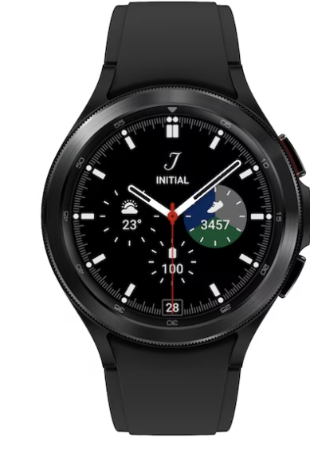

# Galaxy Black Classic Bluetooth Smart Watch Compatible with Android - R890NZKAINU

**18999**

#### PRODUCT DETAILS

* Galaxy Watch4 Classic comes with Bioelectrical Impedance Analysis (BIA) that lets you measure body composition.
* Key health monitoring features include Advanced Sleep Analysis, Health monitoring and enhanced Fitness Tracking.
* With WearOS, experience enriched App availability and connectivity. (Only compatible with Android)

#### Size & Fit

Dial width: 42 mm  
Strap width: 20 mm

Display

Digital

Dial Shape

Round

5.NOISE

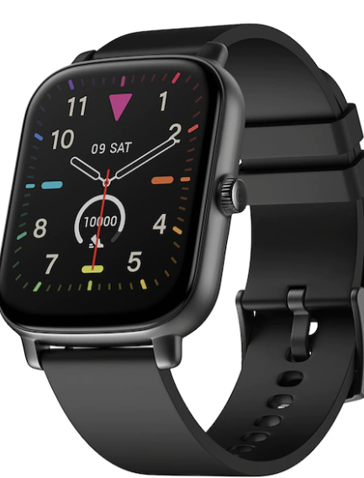

# Black ColorFit Icon Buzz Bluetooth Calling Smart Watch with Voice Assistance

**₹1499**

#### PRODUCT DETAILS

ColorFit Icon Buzz Bluetooth Calling Smart Watch with Voice Assistance  
VAN: wrb-sw-colorfiticonbuzz-std-blk_blk  
Features:

* Bluetooth calling: Make the smart call with Noises first Bluetooth calling smartwatch, loaded with smart features.
* Voice Assistance (AI voice assistance): From making calls, playing music, checking the weather, let your smartwatch do as you command,
* 1.69 TFT LCD display:
* In-built games: ColorFit Icon Buzz is more than just fitness, its your partner in fun, with 2 in-built games.
* Noise Health Suite: Keep a closer eye on your health with ColorFit Icon Buzz, that comes with SpO2, sleep and 24/7 heart rate monitor.
* Up to 7-day battery
* 100+ watch faces: More than 100 cloud-based & customisable watch faces
* IP67 Waterproof
* Weather report
* Display
* Digital
* Dial Shape
* Rectangular